**W5-S2** PRACTICE

*FORMS & INPUTS*

## *What are the objectives for this session?*

* Learn and use various **HTML form input types**
  + *text, checkbox, radio, dropdown, text area, range, color, selector etc.*
* Apply basic CSS styles to enhance the appearance of form inputs
  + *borders, colors, padding, margins etc.*
* Use:  **:focus :hover** : **checked :checked :indeterminate** CSS pseudo-classes

## *How to start?*

* Download **the start code** from the LMS
* Open the folder in VS Code

## *How to submit your work?*

* **Push** your final codeon **your GitHub repository**
* Then **attach the GitHub path** to the MS Team assignment and **turn it in**

## *Are you lost?*

*You can read the following documentation to be ready for this practice:*

* [Guide - WC3 School](https://www.w3schools.com/html/html_forms.asp)
* [The Form element](https://developer.mozilla.org/en-US/docs/Web/HTML/Element/form)
* [HTML Forms](https://www.geeksforgeeks.org/html-forms/)

# **PART 1:** LEARN – 45 MIN

* **Read or watch** resources on internet to learn about **HTML Inputs**:

[Guide - WC3 School](https://www.w3schools.com/html/html_forms.asp)

[The Form element](https://developer.mozilla.org/en-US/docs/Web/HTML/Element/form)

[HTML Forms](https://www.geeksforgeeks.org/html-forms/)

* **Complete** the bellow table.

|  |  |  |
| --- | --- | --- |
| **INPUT TYPE** | **USAGE** | **EXAMPLE** |
| Text | defines a one-line input field for text input | <input type="text"> |
| radio | Select one of many choices | <input type="radio"> |
| checkbox | Select multiple of many choices | <input type="checkbox"> |
| range | Defines a control for entering number whose exact value is not important | <input type="range"> |
| submit | Button for submitting form | <input type="submit"> |
| textarea | Define a multi-line text input control | <textarea></textarea> |
| select | Create a drop-down list | <select></select> |
| color | For user to select color from color picker | <input type="color"> |
| file | Defines a file-select field and a ="Browse" button for file uploads | <input type="file"> |

* **Read or watch** resources on internet to learn about  **Inputs styling**:

<https://www.w3schools.com/css/css_form.asp>

* Complete those **mini-challenges** by writing your code on bellow table:

|  |  |
| --- | --- |
| **MINI CHALLENGES** | **YOUR CODE (HTML + CSS)** |
| Highlight the input field when it is focused | <!DOCTYPE html>  <html lang="en">  <head>  <meta charset="UTF-8">  <meta name="viewport" content="width=device-width, initial-scale=1.0">  <title>Document</title>  <style>  input[type=text] {  outline: none;  padding: 3px 0px 3px 3px;  margin: 5px 1px 3px 0px;  border: 1px solid #DDDDDD;  }    input[type=text]:focus, textarea:focus {  border: 1px solid #1a1a1a;  }  body {  padding: 20px;  }  </style>  </head>  <body>  <form action="#" method="post">    <div>  <label for="fname">First Name</label>  <input type="text" name="fname" id="fname"/>  </div>  <div>  <label for="lname">Last Name</label>  <input type="text" name="lname" id="lname"/>  </div>    </form>  </body>  </html> |
| Change the button background color on hover | input[type=text]{color: #1a1a1a; border:1px solid #DDDDDD; border-radius: 5px;}  input[type=text]:hover{color: #fff; transition: 0.3s ease; border:1px solid blue;background-color: #fff;} |
| Create a search bar with rounded corners and a shadow effect | <!DOCTYPE html>  <html lang="en">  <head>  <meta charset="UTF-8">  <meta name="viewport" content="width=device-width, initial-scale=1.0">  <title>Document</title>  <style>  .search{  border:1px solid #1a1a1a;  border-radius: 6px;  }  .search:hover{  transition: 0.3s ease;  box-shadow: 0 1px 2px #1a1a1a;  }  </style>  </head>  <body>  <input class="search" type="search" placeholder=" Search"/>  </body> |
| Display a different style when the checkbox is checked | <style>  .checkbox:not(:checked) + label {      color: #333;      background: #f9f9f9;      padding: 6px 10px;      border-radius: 8px;      transition: 0.3s ease;  }  .checkbox:checked + label {      color: #4CAF50;      font-weight: bold;      background: #E8F5E9;      padding: 6px 10px;      border-radius: 8px;      transition: 0.3s ease;  }  </style>  <body>      <input class="checkbox" type="checkbox" id="checkbox1">      <label for="checkbox">Chea Ilong</label>      <br><br>      <input class="checkbox" type="checkbox" id="checkbox2">      <label for="checkbox">Chea Dara</label>      <br><br>      <input class="checkbox" type="checkbox" id="checkbox3">      <label for="checkbox">Chea Vanndara</label>  </body> |
| **HARD!**  Style a checkbox to have three states: unchecked, checked, and indeterminate.  TIP  Use CSS pseudo-classes  (:checked and :indeterminate)  for styling. | <body>  .checkbox:indeterminate + label {      color: #FFC107;      font-weight: bold;      background: #FFF8E1;      padding: 6px 10px;      border-radius: 8px;      transition: 0.3s ease;      border: 1px solid #FFC107;  }  </body>  <script>      document.querySelectorAll('.checkbox').forEach((checkbox, index) => {          if (index === 1) {              checkbox.indeterminate = true;          }      });  </script> |

* Some **groups will be selected to present** and **explain** their work to the whole class

# **PART 2:** PRACTICE – 45 MIN

You need to reproduce – *as close as possible* - the bellow table.

Before coding, identify the following point:

* **Elements**: What are the different inputs you will need?
* **Layout**: what kind of CSS layout do you need? Why?
* **Input styling**: What are the styles you need to apply on your inputs?

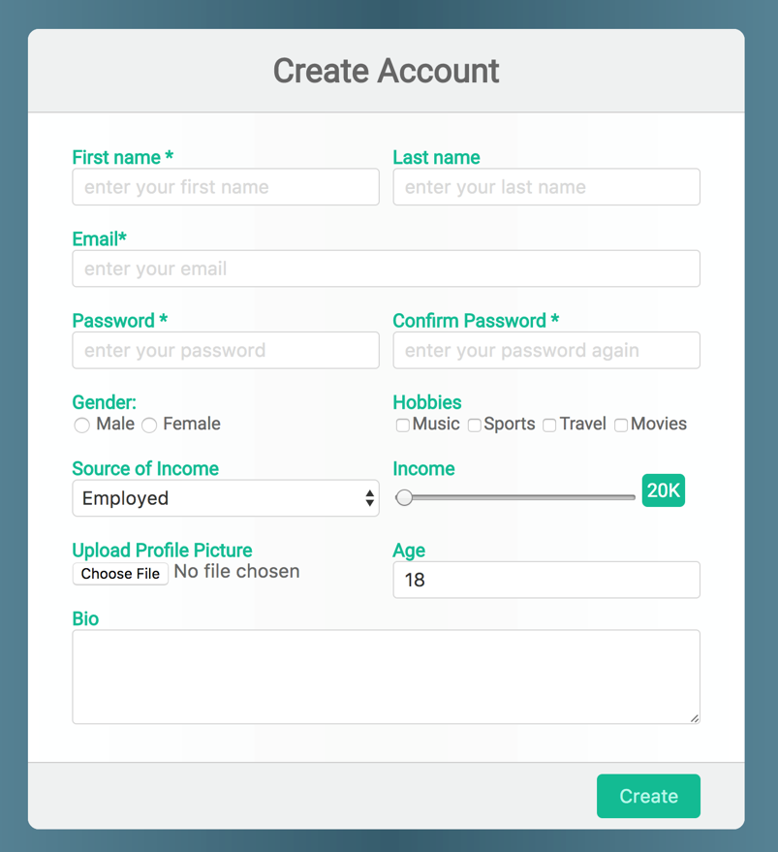

*Be as close as possible from this mock up*

# **PART 3:** THINK + PAIR + SHARE – 90 MIN

***STEP 1: INDIVIDUAL WORK*** *– 15 MIN*

1. Brainstorm a **form idea** based on a *scenario*

*e.g., contact form, login form, survey form, registration form…*

1. List the **elements** you think the form should include

*e.g.: text area, password, color selector, radio button, list…*

1. List any **specific CSS styles** the form should have

*e.g., hover effects, focus styles, alignment, layout, columns, rows…*

***STEP 2: COLLABORATIVE WORK*** *– 45 MIN*

1. Decide on a **single form idea** to develop.
2. **Sketch the form structure** and styling on paper
3. Start implementing the **HTML** structure and **CSS** styles collaboratively.

***STEP 3: SHARE*** *– 30 MIN*

* Pair with another team and demonstrates your project, explaining:
  + The **form’s purpose** and use case
  + How you structured the **HTML**
  + The **CSS** techniques used for styling
  + The **challenges you have faced** and how you resolved them
* Some **groups will be selected to present** their work to the whole class